SNAP Papers 2007
The leading brand of artificial sweetener in India, ‘Sugar Free’ is owned by
Cadila
Cipla
Monsanto
Glaxo
Monsoon is caused by
Rise in temperature
Movements of cloud
Impact of Summer temperature on the sea
Seasonal reversal of winds
An Indian company manufacturing automobiles for Mitsubishi is
Bajaj Tempo
Tata Motors
Hindustan Motors
Mahindra
The name “Koneru Humpy” is associated with which of the following sport?
Weight Lifting
Chess
Cricket
Badminton
The new coin ‘Rupiya’ was issued for the first time by
Sher Shah Suri
Mohammed Shah Tughlaq
Ala ud din Khilhi
Akbar
One of the following allows an individual to start and continue to share regularly any of his/her own personal experience, knowledge, opinion or thought with the internet community?
Email
Blog
Chat
Portal
Phishing is
None of these
A stem cell
A fraudulent way of getting the PIN and bank passwords using emails
A Govt. plan
In the sports world, the sobriquet ‘Indo-Pak Express’ is applied to
Shree Santh and Shoaib Akhtar
Rohan Bopanna and Shahar Peer
Rohan Bopanna and Aisam-Ul- Haq Quareshi
Sania Mirza and Shahar Peer
A film that has not been directed by Mira Nair is
Monsoon Wedding
Earth
Kamasutra
Salaam Bombay
In banking terminology, CRR means
Cash Rating Ratio
Credit Rating Ratio
Cash Reserve Ratio
Credit Reserve Ratio
Some of the large deals entered into by IT majors in India (all are billion dollar deals) are listed here as options. Which one is not?
TCS-Nielson
Infosys-ABN AMRO
Tech Mahindra-BT
IBM-Bharti
A suicide car bomb caused havoc in England in July 2007 at the which airport?
Nottingham
Heathrow
Glasgow
Burmingham
Pakistan has signed Free Trade Agreement (FTA ) and a five year investment package with
Russia
European Union
China
USA
Major oil finds in India have been reported in
Cauvery Basin
Krishna Godavari Basin
LowerAssamValley.
Rajasthan Desert
Major oil finds in India have been reported in
Cauvery Basin
Krishna Godavari Basin
LowerAssamValley.
Rajasthan Desert
The propagation of radio signals is greatly influenced by
ionosphere
troposphere
thermosphere
exosphere
According to Dun and Bradsstreet which one of the following is the largest employer among Indian ITes and BPO companies?
Wipro BPO
IBM Daksh
Genpact
Accenture Services
“In God we trust, the rest have to bring data on the table.” This statement was made by the famous industrialist
Dhirubhai Ambani
Aditya Birla
J.R.D.Tata
Narayan Murthy
The runner-up in the recent Vice-Presidential election was
Mr. Praful Patel
Dr. Najma Heptullah
Mr. Bhairon Singh Shekhawat
Mr. Hameed Ansari
Which of the following is not provided in the constitution?
Election Commission
Public Service Commission
Finance Commission
Planning Commission
When did Governor General’s rule end in India?
9th August 1948
2nd October 1950
26th January 1950
15th August 1947
The newspaper which was recently voted as the largest selling newspaper in the world is
The Times of India
The London Times
The New York Times
The Los Angeles Times
Which of the following countries is the top source of FDI inflows into India at present?
UK
USA
Mauritius
Singapore
The human cell contains
48 chromosomes
44 chromosomes
23 chromosomes
46 chromosomes
In year 2006, the three largest economies in the world were
USA, China & Japan
USA, Japan & Germany
USA, UK & France
USA, Uk & Germany
Identify an entry that is reversed in terms of the forex rates for US Dollar on a day recently.
1 US $ = Rs. 39.35
1 US $ = Â¥ 114
1US$=â‚¬1.42
1 US $ = Â£ 0.48
26. Starbucks, the coffee chain retailer’s name is inspired from which book?
Mobydick
Uncle Tom’s Cabin
None of the above
The Scarlet Letter
A major US toy manufacturer which suffered a breakdown in supply chain from China on account of legally unacceptable toxic substances in its products is
Mattel Toys
Funskool Toys
Universal Toys
Leo Toys
Bollywood name has been granted as a trademark to which US based Media and Entertainment company by Indian Trademark Registry?
Disney Enterprises
Universal Studios
Miramax
Viacom
Lakshmi Mittal, the famous NRI industrialist, is partnering with Govt. of India for which of the following big projects?
Biotechnology
Oil Refinery
Atomic Power Plant
Mining
Tyeb Mehta, Nand Lal Bose and Majit Bewa are
English Poets
Photographers
Painters
Classical Singers
Zapak Digital Entertainment (a gaming venture) belongs to which business group?
Anil Dhirubhai Ambani Enterprises
Balaji Telefilm
Zee TV
UTV
In August 2007, Chennai High Court passed a landmark judgment that may have far reaching consequences on pharmaceuticals industry, dismissing a writ petition filed by
Ranbaxy
Novartis
Glaxo
Sandoz
The busiest port in the world today is
Port of Shangai
Port of Dubai
Port of Rotterdam
Port of Singapore
In recent months the monks of Myanmar marched the streets of Yangon in hundreds
To spread the message of peace
To take the normal route for alms
To celebrate Buddha purnima
To protest against the government that was ruling
To recover the national loss suffered by small investors in the IPO allotment scam from the National Securities Depository Services Ltd, Central Depository Services Ltd and eight depository participants, a second interim order was passed by
SEBI
AFMI
Supreme Court
RBI
Indian Broadcasting Service was renamed in 1936 as
Akshwani
Doorwani
Nabhowani
All India Radio
Indian Broadcasting Service was renamed in 1936 as
Akshwani
Doorwani
Nabhowani
All India Radio
Which of the following is not a principal organ of the UNO?
General Assembly
Security Council
World Health Organization
Trusteeship Council
Who was the composer of the classical composition ‘Moonlight Sonata’?
Handel
Joseph Haydn
Ludwig Van Beethoven
Johann Bach
During the year 2006-07 Indian Railways earned a profit of approximately
Rs. 14,000 crores
Rs. 16,500 crores
Rs. 20,000 crores
Rs. 18,000 crores
Egg is a rich source of nutrients except
Vitamin D
Vitamin C
Protein
None of the above
Directions :Read the following passage and answer within its context
The world dismisses curiosity by calling it idle, or mere idle curiosity – even though curious persons are seldom idle. Parents do their best to extinguish curiosity in their children because it makes life difficult to be faced every day with a string of answerable questions about what makes fire hot or why grass grows. Children whose curiosity survives parental discipline are invited to join our university. Within the university, they go on asking their questions and trying to find the answers. In the eyes of a scholar, that is mainly what a university is for. Some of the questions that scholars ask seem to the world to be scarcely worth asking let alone answering. They ask questions too minute and specialized for you and me to understand without years of explanation. If the world inquires of one of them why he wants to know the answer to a particular question he may say, especially if he is a scientist, that the answer will in some obscure way make possible a new machine or weapon or gadget. He talks that way because he knows that the world understands and respects utility. But to you who are now part of the university, he will say that he wants to know the answer simply because he does not know it. The way a mountain climber wants to climb a mountain simply because it is there. Similarly a historian when asked by outsiders why he studies history may come out with argument that he has learnt to repeat on such occasions. Something about knowledge of the past making it possible to understand the present and mould the future. But if you really want to know why a historian studies the past, the answer is much simpler: something happened, and he would like to know what. All this does not mean that the answers which scholars find to their questions have no consequences. They may have enormous consequences but these seldom form the reason for asking the question or pursuing the answers. It is true that scholars can be put to work answering questions for the sake of the consequences as thousands are working now, for example, in search of a cure for cancer. But this is not the primary function of the scholar, for the consequences are usually subordinate to the satisfaction of curiosity.
Common people consider some of the questions asked by scholars as unimportant
Because the common man does’t understand questions without years of explanations.
Scholars ask very minute, specialized questions beyond the comprehension of the common man.
Because the question is related to new machines and gadgets.
Since they are not worth asking of answering.
Directions :Read the following passage and answer within its context
The world dismisses curiosity by calling it idle, or mere idle curiosity – even though curious persons are seldom idle. Parents do their best to extinguish curiosity in their children because it makes life difficult to be faced every day with a string of answerable questions about what makes fire hot or why grass grows. Children whose curiosity survives parental discipline are invited to join our university. Within the university, they go on asking their questions and trying to find the answers. In the eyes of a scholar, that is mainly what a university is for. Some of the questions that scholars ask seem to the world to be scarcely worth asking let alone answering. They ask questions too minute and specialized for you and me to understand without years of explanation. If the world inquires of one of them why he wants to know the answer to a particular question he may say, especially if he is a scientist, that the answer will in some obscure way make possible a new machine or weapon or gadget. He talks that way because he knows that the world understands and respects utility. But to you who are now part of the university, he will say that he wants to know the answer simply because he does not know it. The way a mountain climber wants to climb a mountain simply because it is there. Similarly a historian when asked by outsiders why he studies history may come out with argument that he has learnt to repeat on such occasions. Something about knowledge of the past making it possible to understand the present and mould the future. But if you really want to know why a historian studies the past, the answer is much simpler: something happened, and he would like to know what. All this does not mean that the answers which scholars find to their questions have no consequences. They may have enormous consequences but these seldom form the reason for asking the question or pursuing the answers. It is true that scholars can be put to work answering questions for the sake of the consequences as thousands are working now, for example, in search of a cure for cancer. But this is not the primary function of the scholar, for the consequences are usually subordinate to the satisfaction of curiosity.
In the statement ‘that is mainly what a university is for’ ‘that’ refers to
Parents refusal to answer questions.
The aim and scope of the university to provide an opportunity to curious minds to find out the answers to their questions.
Children’s curiosity that survives parents structures.
Questions not worth answering.
Directions :Read the following passage and answer within its context
The world dismisses curiosity by calling it idle, or mere idle curiosity – even though curious persons are seldom idle. Parents do their best to extinguish curiosity in their children because it makes life difficult to be faced every day with a string of answerable questions about what makes fire hot or why grass grows. Children whose curiosity survives parental discipline are invited to join our university. Within the university, they go on asking their questions and trying to find the answers. In the eyes of a scholar, that is mainly what a university is for. Some of the questions that scholars ask seem to the world to be scarcely worth asking let alone answering. They ask questions too minute and specialized for you and me to understand without years of explanation. If the world inquires of one of them why he wants to know the answer to a particular question he may say, especially if he is a scientist, that the answer will in some obscure way make possible a new machine or weapon or gadget. He talks that way because he knows that the world understands and respects utility. But to you who are now part of the university, he will say that he wants to know the answer simply because he does not know it. The way a mountain climber wants to climb a mountain simply because it is there. Similarly a historian when asked by outsiders why he studies history may come out with argument that he has learnt to repeat on such occasions. Something about knowledge of the past making it possible to understand the present and mould the future. But if you really want to know why a historian studies the past, the answer is much simpler: something happened, and he would like to know what. All this does not mean that the answers which scholars find to their questions have no consequences. They may have enormous consequences but these seldom form the reason for asking the question or pursuing the answers. It is true that scholars can be put to work answering questions for the sake of the consequences as thousands are working now, for example, in search of a cure for cancer. But this is not the primary function of the scholar, for the consequences are usually subordinate to the satisfaction of curiosity.
According to the passage the general public respects
Any useful invention.
A scientist who invents gadgets and machines for them.
Any invention that makes life easier for them.
New inventions.
Directions :Read the following passage and answer within its context
The world dismisses curiosity by calling it idle, or mere idle curiosity – even though curious persons are seldom idle. Parents do their best to extinguish curiosity in their children because it makes life difficult to be faced every day with a string of answerable questions about what makes fire hot or why grass grows. Children whose curiosity survives parental discipline are invited to join our university. Within the university, they go on asking their questions and trying to find the answers. In the eyes of a scholar, that is mainly what a university is for. Some of the questions that scholars ask seem to the world to be scarcely worth asking let alone answering. They ask questions too minute and specialized for you and me to understand without years of explanation. If the world inquires of one of them why he wants to know the answer to a particular question he may say, especially if he is a scientist, that the answer will in some obscure way make possible a new machine or weapon or gadget. He talks that way because he knows that the world understands and respects utility. But to you who are now part of the university, he will say that he wants to know the answer simply because he does not know it. The way a mountain climber wants to climb a mountain simply because it is there. Similarly a historian when asked by outsiders why he studies history may come out with argument that he has learnt to repeat on such occasions. Something about knowledge of the past making it possible to understand the present and mould the future. But if you really want to know why a historian studies the past, the answer is much simpler: something happened, and he would like to know what. All this does not mean that the answers which scholars find to their questions have no consequences. They may have enormous consequences but these seldom form the reason for asking the question or pursuing the answers. It is true that scholars can be put to work answering questions for the sake of the consequences as thousands are working now, for example, in search of a cure for cancer. But this is not the primary function of the scholar, for the consequences are usually subordinate to the satisfaction of curiosity.
The writer compares the scientist to
A scholar.
A historian.
A mountain climber
A historian and mountain climber.
Directions :Read the following passage and answer within its context
The world dismisses curiosity by calling it idle, or mere idle curiosity – even though curious persons are seldom idle. Parents do their best to extinguish curiosity in their children because it makes life difficult to be faced every day with a string of answerable questions about what makes fire hot or why grass grows. Children whose curiosity survives parental discipline are invited to join our university. Within the university, they go on asking their questions and trying to find the answers. In the eyes of a scholar, that is mainly what a university is for. Some of the questions that scholars ask seem to the world to be scarcely worth asking let alone answering. They ask questions too minute and specialized for you and me to understand without years of explanation. If the world inquires of one of them why he wants to know the answer to a particular question he may say, especially if he is a scientist, that the answer will in some obscure way make possible a new machine or weapon or gadget. He talks that way because he knows that the world understands and respects utility. But to you who are now part of the university, he will say that he wants to know the answer simply because he does not know it. The way a mountain climber wants to climb a mountain simply because it is there. Similarly a historian when asked by outsiders why he studies history may come out with argument that he has learnt to repeat on such occasions. Something about knowledge of the past making it possible to understand the present and mould the future. But if you really want to know why a historian studies the past, the answer is much simpler: something happened, and he would like to know what. All this does not mean that the answers which scholars find to their questions have no consequences. They may have enormous consequences but these seldom form the reason for asking the question or pursuing the answers. It is true that scholars can be put to work answering questions for the sake of the consequences as thousands are working now, for example, in search of a cure for cancer. But this is not the primary function of the scholar, for the consequences are usually subordinate to the satisfaction of curiosity.
The primary function of a scholar is different from the search for a cure for cancer because
The primary function of a scholar is satisfaction of his mental curiosity, while research involving a cure for cancer demands a constant, systematic and planned pursuit by several scholars.
Several scholars work for a cancer cure while a single scholar works with a selfish motive.
The answer sought by the scholar is selfish unlike the consequences of cancer research which are for the commonweal.
The answers to the scholar’s question have no consequence unlike the results of the research involving a cure for cancer.
Directions :Read the following passage and answer within its context
The world dismisses curiosity by calling it idle, or mere idle curiosity – even though curious persons are seldom idle. Parents do their best to extinguish curiosity in their children because it makes life difficult to be faced every day with a string of answerable questions about what makes fire hot or why grass grows. Children whose curiosity survives parental discipline are invited to join our university. Within the university, they go on asking their questions and trying to find the answers. In the eyes of a scholar, that is mainly what a university is for. Some of the questions that scholars ask seem to the world to be scarcely worth asking let alone answering. They ask questions too minute and specialized for you and me to understand without years of explanation. If the world inquires of one of them why he wants to know the answer to a particular question he may say, especially if he is a scientist, that the answer will in some obscure way make possible a new machine or weapon or gadget. He talks that way because he knows that the world understands and respects utility. But to you who are now part of the university, he will say that he wants to know the answer simply because he does not know it. The way a mountain climber wants to climb a mountain simply because it is there. Similarly a historian when asked by outsiders why he studies history may come out with argument that he has learnt to repeat on such occasions. Something about knowledge of the past making it possible to understand the present and mould the future. But if you really want to know why a historian studies the past, the answer is much simpler: something happened, and he would like to know what. All this does not mean that the answers which scholars find to their questions have no consequences. They may have enormous consequences but these seldom form the reason for asking the question or pursuing the answers. It is true that scholars can be put to work answering questions for the sake of the consequences as thousands are working now, for example, in search of a cure for cancer. But this is not the primary function of the scholar, for the consequences are usually subordinate to the satisfaction of curiosity.
Idle curiosity means
Casual curiosity.
Curiosity is lazy
Curiosity is apt.
Idle people are curious.
Find the correct match of definition/meaning with usage for the word:
Would
Definition / meaning | Usage

1) willingness |  |  | 5) He would go for a walk even when it was raining.
2) obstinacy persistence |  |  | 6) He would do as you say.
3) determination |  |  | 7) He beat the ox, but it wouldn’t move.
4) improbable or real condition |  |  | 8) If you came across a snake what would you do?
 | 1-5,2-7,3-8,4-6
 | 1-8,2-5,3-6,4-6
 | 1-7,2-5,3-6,4-8
 | 1-6,2-7,3-5,4-8
Choose the most appropriate passive construction of the sentence:
‘He is doing his job well.’
His job is done well by him.
His job is being done well.
His job is being well done.
He has been doing his job well.
There are three underlined words below, followed by their usages. Determine the sentences, in which the use of words is correct or appropriate :
Pray. Prey. Prying
A. If you pray with faith, they say, it will be answered.
B. He has fallen a prey to cheats
C. Prying into the affairs of others is bad
A, B and C
B and C
A and C
A and B
Directions : The following is an excerpt from a recent article by David Ewing Duncan. Read the passage and answer the questions within its context
Eye surgeon Virendar Sangwan has perfected a procedure so cutting-edge that most who have tried it have failed. In an operating theatre in the central Indian city of Hyderabad, he surgically implants corneas grown in a petri dish from stem cells by his colleague Geeta Vemuganti in patients with damaged eyes. Together they perform about 80 corneal regeneration procedures a year, making the L.V. Prasad Eye Institute, where they work, one of the most prolific facilities in the world using stem cells to regenerate tissues of any kind.
The Sangwan-Vemuganti team uses stem cells found in the tissues of living adults, not ones derived from embryos. Teams all over the world are working with adult stem cells, trying to coax them to regrow cells in hearts, brains, livers and other organs, but progress is slow. Besides corneas, scientists have had some success regrowing skin cells and bone tissues, but those procedures remain experimental. “A number of programs around the world have tried to perfect this treatment, but they have had bad outcomes,” says University of Cincinnati eye surgeon and stem cell specialist Edward Holland. “It is impressive what they are doing at Prasad.”
In addition to the Hyderabad project, only Holland’s program and a half-dozen others in the world conduct operations using corneas grown from stem cells.
The treatment uses stem cells harvested from the limbus, located where the cornea touches the white of the eye. For those with damaged corneas, these cells – called “limbic” and “conjunctiva” – are harvested from a patients good eye, if he has one, or from a close relative. They are placed in a petri dish and chemically tweaked to grow into the lower layer of a cornea, called epithelium. It is then transplanted into the eye of the patient where in most cases it takes hold and grows. In 56% of the cases at the Prasad Institute, patient could still see clearly after 40 months later.
Indians are well known for reverse engineering, meaning they can deduce how drugs are made in order to produce generic versions. But in this case, Sangwan and Vemuganti, a pathologist, developed the technique on their own from reading papers and running experiments in the lab. Sangwan says he had a number of patients with burned eyes who could not helped with standard corneal transplants from cadavers, so he persuaded Vemuganti to try growing corneas in her lab. “You know how to grow cells, and I know how to do the transplant surgery.” Vemuganti recalls him saying. “Why don’t we work together?” She smiles and shakes her head. “I had no clue if this was going to work.”
Vemuganti’s major innovation was developing a platform on which to grow corneas. First she designed a circular glass tube about the size of a stack of coins. Then she overlaid the glass with tissue from a human placenta which is “a good surface to grow corneas on.” She says. After that she placed stem cells in four places around a circle, added a growth medium, and watched the corneas begin to grow.
Commercial interests among stem cell companies for the procedure has been scant because of the perceived small volume of patients, says venture capitalist Antoun Nabhan of Bay Capital, who sits on the board of Cellerant, a leading stem cell company in San Carlos. Calif. But corneal stem cell treatment may have wider applications, say ophthalmologist Ivan Schwab of Unversity of California at Davis. “These stem cells are similar to others in the body that make mucous membrane,” he say. “These techniques of growing stem cells might one day be used to treat mucous- membrane tissue in the sinuses, bladder, and other organs.”
Sangwan-Vemuganti procedure is carried out on
Patients with damaged corneas
None of the above
Patients requiring any corneal transplant
Patients with damaged eyes of any kind
Directions : The following is an excerpt from a recent article by David Ewing Duncan. Read the passage and answer the questions within its context
Eye surgeon Virendar Sangwan has perfected a procedure so cutting-edge that most who have tried it have failed. In an operating theatre in the central Indian city of Hyderabad, he surgically implants corneas grown in a petri dish from stem cells by his colleague Geeta Vemuganti in patients with damaged eyes. Together they perform about 80 corneal regeneration procedures a year, making the L.V. Prasad Eye Institute, where they work, one of the most prolific facilities in the world using stem cells to regenerate tissues of any kind.
The Sangwan-Vemuganti team uses stem cells found in the tissues of living adults, not ones derived from embryos. Teams all over the world are working with adult stem cells, trying to coax them to regrow cells in hearts, brains, livers and other organs, but progress is slow. Besides corneas, scientists have had some success regrowing skin cells and bone tissues, but those procedures remain experimental. “A number of programs around the world have tried to perfect this treatment, but they have had bad outcomes,” says University of Cincinnati eye surgeon and stem cell specialist Edward Holland. “It is impressive what they are doing at Prasad.”
In addition to the Hyderabad project, only Holland’s program and a half-dozen others in the world conduct operations using corneas grown from stem cells.
The treatment uses stem cells harvested from the limbus, located where the cornea touches the white of the eye. For those with damaged corneas, these cells – called “limbic” and “conjunctiva” – are harvested from a patients good eye, if he has one, or from a close relative. They are placed in a petri dish and chemically tweaked to grow into the lower layer of a cornea, called epithelium. It is then transplanted into the eye of the patient where in most cases it takes hold and grows. In 56% of the cases at the Prasad Institute, patient could still see clearly after 40 months later.
Indians are well known for reverse engineering, meaning they can deduce how drugs are made in order to produce generic versions. But in this case, Sangwan and Vemuganti, a pathologist, developed the technique on their own from reading papers and running experiments in the lab. Sangwan says he had a number of patients with burned eyes who could not helped with standard corneal transplants from cadavers, so he persuaded Vemuganti to try growing corneas in her lab. “You know how to grow cells, and I know how to do the transplant surgery.” Vemuganti recalls him saying. “Why don’t we work together?” She smiles and shakes her head. “I had no clue if this was going to work.”
Vemuganti’s major innovation was developing a platform on which to grow corneas. First she designed a circular glass tube about the size of a stack of coins. Then she overlaid the glass with tissue from a human placenta which is “a good surface to grow corneas on.” She says. After that she placed stem cells in four places around a circle, added a growth medium, and watched the corneas begin to grow.
Commercial interests among stem cell companies for the procedure has been scant because of the perceived small volume of patients, says venture capitalist Antoun Nabhan of Bay Capital, who sits on the board of Cellerant, a leading stem cell company in San Carlos. Calif. But corneal stem cell treatment may have wider applications, say ophthalmologist Ivan Schwab of Unversity of California at Davis. “These stem cells are similar to others in the body that make mucous membrane,” he say. “These techniques of growing stem cells might one day be used to treat mucous- membrane tissue in the sinuses, bladder, and other organs.”
The world recognises this Indian innovation because Indian scientists are normally known
As they are good at carrying out experiments to create generic drugs.
As they are good researchers of drugs.
To be good at analysing and finding out a method of how an existing drug is made.
As they are able to carry out drug trials on large samples.
Directions : The following is an excerpt from a recent article by David Ewing Duncan. Read the passage and answer the questions within its context
Eye surgeon Virendar Sangwan has perfected a procedure so cutting-edge that most who have tried it have failed. In an operating theatre in the central Indian city of Hyderabad, he surgically implants corneas grown in a petri dish from stem cells by his colleague Geeta Vemuganti in patients with damaged eyes. Together they perform about 80 corneal regeneration procedures a year, making the L.V. Prasad Eye Institute, where they work, one of the most prolific facilities in the world using stem cells to regenerate tissues of any kind.
The Sangwan-Vemuganti team uses stem cells found in the tissues of living adults, not ones derived from embryos. Teams all over the world are working with adult stem cells, trying to coax them to regrow cells in hearts, brains, livers and other organs, but progress is slow. Besides corneas, scientists have had some success regrowing skin cells and bone tissues, but those procedures remain experimental. “A number of programs around the world have tried to perfect this treatment, but they have had bad outcomes,” says University of Cincinnati eye surgeon and stem cell specialist Edward Holland. “It is impressive what they are doing at Prasad.”
In addition to the Hyderabad project, only Holland’s program and a half-dozen others in the world conduct operations using corneas grown from stem cells.
The treatment uses stem cells harvested from the limbus, located where the cornea touches the white of the eye. For those with damaged corneas, these cells – called “limbic” and “conjunctiva” – are harvested from a patients good eye, if he has one, or from a close relative. They are placed in a petri dish and chemically tweaked to grow into the lower layer of a cornea, called epithelium. It is then transplanted into the eye of the patient where in most cases it takes hold and grows. In 56% of the cases at the Prasad Institute, patient could still see clearly after 40 months later.
Indians are well known for reverse engineering, meaning they can deduce how drugs are made in order to produce generic versions. But in this case, Sangwan and Vemuganti, a pathologist, developed the technique on their own from reading papers and running experiments in the lab. Sangwan says he had a number of patients with burned eyes who could not helped with standard corneal transplants from cadavers, so he persuaded Vemuganti to try growing corneas in her lab. “You know how to grow cells, and I know how to do the transplant surgery.” Vemuganti recalls him saying. “Why don’t we work together?” She smiles and shakes her head. “I had no clue if this was going to work.”
Vemuganti’s major innovation was developing a platform on which to grow corneas. First she designed a circular glass tube about the size of a stack of coins. Then she overlaid the glass with tissue from a human placenta which is “a good surface to grow corneas on.” She says. After that she placed stem cells in four places around a circle, added a growth medium, and watched the corneas begin to grow.
Commercial interests among stem cell companies for the procedure has been scant because of the perceived small volume of patients, says venture capitalist Antoun Nabhan of Bay Capital, who sits on the board of Cellerant, a leading stem cell company in San Carlos. Calif. But corneal stem cell treatment may have wider applications, say ophthalmologist Ivan Schwab of Unversity of California at Davis. “These stem cells are similar to others in the body that make mucous membrane,” he say. “These techniques of growing stem cells might one day be used to treat mucous- membrane tissue in the sinuses, bladder, and other organs.”
The pathologist, Vemuganti, started growing cornea in a petri dish
By following the instruction of the transplant surgeon.
By following procedures published in research papers
By experimenting with procedures published in journals
By inventing a totally new procedure
Directions : The following is an excerpt from a recent article by David Ewing Duncan. Read the passage and answer the questions within its context
Eye surgeon Virendar Sangwan has perfected a procedure so cutting-edge that most who have tried it have failed. In an operating theatre in the central Indian city of Hyderabad, he surgically implants corneas grown in a petri dish from stem cells by his colleague Geeta Vemuganti in patients with damaged eyes. Together they perform about 80 corneal regeneration procedures a year, making the L.V. Prasad Eye Institute, where they work, one of the most prolific facilities in the world using stem cells to regenerate tissues of any kind.
The Sangwan-Vemuganti team uses stem cells found in the tissues of living adults, not ones derived from embryos. Teams all over the world are working with adult stem cells, trying to coax them to regrow cells in hearts, brains, livers and other organs, but progress is slow. Besides corneas, scientists have had some success regrowing skin cells and bone tissues, but those procedures remain experimental. “A number of programs around the world have tried to perfect this treatment, but they have had bad outcomes,” says University of Cincinnati eye surgeon and stem cell specialist Edward Holland. “It is impressive what they are doing at Prasad.”
In addition to the Hyderabad project, only Holland’s program and a half-dozen others in the world conduct operations using corneas grown from stem cells.
The treatment uses stem cells harvested from the limbus, located where the cornea touches the white of the eye. For those with damaged corneas, these cells – called “limbic” and “conjunctiva” – are harvested from a patients good eye, if he has one, or from a close relative. They are placed in a petri dish and chemically tweaked to grow into the lower layer of a cornea, called epithelium. It is then transplanted into the eye of the patient where in most cases it takes hold and grows. In 56% of the cases at the Prasad Institute, patient could still see clearly after 40 months later.
Indians are well known for reverse engineering, meaning they can deduce how drugs are made in order to produce generic versions. But in this case, Sangwan and Vemuganti, a pathologist, developed the technique on their own from reading papers and running experiments in the lab. Sangwan says he had a number of patients with burned eyes who could not helped with standard corneal transplants from cadavers, so he persuaded Vemuganti to try growing corneas in her lab. “You know how to grow cells, and I know how to do the transplant surgery.” Vemuganti recalls him saying. “Why don’t we work together?” She smiles and shakes her head. “I had no clue if this was going to work.”
Vemuganti’s major innovation was developing a platform on which to grow corneas. First she designed a circular glass tube about the size of a stack of coins. Then she overlaid the glass with tissue from a human placenta which is “a good surface to grow corneas on.” She says. After that she placed stem cells in four places around a circle, added a growth medium, and watched the corneas begin to grow.
Commercial interests among stem cell companies for the procedure has been scant because of the perceived small volume of patients, says venture capitalist Antoun Nabhan of Bay Capital, who sits on the board of Cellerant, a leading stem cell company in San Carlos. Calif. But corneal stem cell treatment may have wider applications, say ophthalmologist Ivan Schwab of Unversity of California at Davis. “These stem cells are similar to others in the body that make mucous membrane,” he say. “These techniques of growing stem cells might one day be used to treat mucous- membrane tissue in the sinuses, bladder, and other organs.”
In the context of the passage choose the correct set of meanings for the words: PLATFORM and GENERIC
Lab experiments; without a brand name
Method; related to genes
Methodology; without a brand name
Lab table; related to genes
Choose the option which is closest in meaning to the word SUBTLE
Elusive
Dangerous
Innocent
Insidious
The following sentence has a missing punctuation mark, choose the right answer.
My mother who is from the village is very superstitious.
Apostrophe
Comma
Brackets
Semicolon
For the pair of sentences below choose the right option.
1. Those are them.
2. Those are they.
Both sentences are incorrect.
Both sentences are correct.
The first sentence has an error.
The second sentence is erroneous.
Directions : Read the following passage and answer within its context.
TRIPs agreement provides a comprehensive set of global trade rules for the protection of copyright patents, trademarks, industrial designs, trade secrets, semiconductor lay out designs, and geographical indications, that apply to all the number- countries irrespective of their levels of development, natural and human endowments and history. Every member-country has been asked by the WTO to amend its national patent law to confirm to that universal globalized format for legislation relating to pharmaceutical, agrochemical, food, alloys, etc.
Under Article 65, the developed countries have been asked to change their laws within another five years, and the less developed countries within an additional five years. The least developed countries have been asked to make those changes by 2005AD.
This attempt at global standardisation and uniformity by way of TRIP’s agreement is in conflict with the main thrust of the Rio Earth Summit of 1992 that set out the conditions for sustainable development. These two reveal two contrasting types of international approaches and norms.
While the 1992 Earth Summit and the 1993 convention on biodiversity (CBD) focused on ‘diversity’ as being fundamental to sustain life and development, TRIPs and WTO are pushing for ‘conformity’ to international standardized norms on patents, services, labour, investment and what not irrespective of their history, ecology, level of economic development, etc. But despite their diametrically opposed viewpoints, 170 countries signed CBD upholding the need for diversity, and 50 countries signed the TRIPs agreement in 1994 claiming the urgency of uniformity, with a very large element of common names (130) in both.
The convention on bio-diversity (CBD) in its Article 16.5 specifically asserts that intellectual property right must not be in conflict with conservation and sustainable use of bio-diversity, a provision that has been totally ignored by those who composed the TRIPs agreement. While in case of agriculture the higher yield of patented products induces the farmers to switch form a more varied production pattern, the resulting narrowing of genetic base makes the economy and society more vulnerable to plant disease and epidemics. It is true that the move towards cultivation of a smaller number of higher yielding varieties and the uniform spread of the same variety over a large space predates the present debate on patent, particularly since the introduction of the green revolution technology in the mid-sixties, but there can be no doubt that the latter has brought about a qualitative change in the scenario and has created possibility of a vast quantitative change too in that direction. So far no attempt has been made to reconcile the two conflicting approaches of CBD and TRIPs. If diversity is so important for sustaining life, how can WTO demand conformity to standardised global formats?.
The author points out that intellectual property rights and their administration mechanism
Is being sustained by global bio-diversity
Is throttling the interest of global bio-diversity
Is working to help sustain global bio-diversity
Is what the global bio-diversity needs
Directions : Read the following passage and answer within its context.
TRIPs agreement provides a comprehensive set of global trade rules for the protection of copyright patents, trademarks, industrial designs, trade secrets, semiconductor lay out designs, and geographical indications, that apply to all the number- countries irrespective of their levels of development, natural and human endowments and history. Every member-country has been asked by the WTO to amend its national patent law to confirm to that universal globalized format for legislation relating to pharmaceutical, agrochemical, food, alloys, etc.
Under Article 65, the developed countries have been asked to change their laws within another five years, and the less developed countries within an additional five years. The least developed countries have been asked to make those changes by 2005AD.
This attempt at global standardisation and uniformity by way of TRIP’s agreement is in conflict with the main thrust of the Rio Earth Summit of 1992 that set out the conditions for sustainable development. These two reveal two contrasting types of international approaches and norms.
While the 1992 Earth Summit and the 1993 convention on biodiversity (CBD) focused on ‘diversity’ as being fundamental to sustain life and development, TRIPs and WTO are pushing for ‘conformity’ to international standardized norms on patents, services, labour, investment and what not irrespective of their history, ecology, level of economic development, etc. But despite their diametrically opposed viewpoints, 170 countries signed CBD upholding the need for diversity, and 50 countries signed the TRIPs agreement in 1994 claiming the urgency of uniformity, with a very large element of common names (130) in both.
The convention on bio-diversity (CBD) in its Article 16.5 specifically asserts that intellectual property right must not be in conflict with conservation and sustainable use of bio-diversity, a provision that has been totally ignored by those who composed the TRIPs agreement. While in case of agriculture the higher yield of patented products induces the farmers to switch form a more varied production pattern, the resulting narrowing of genetic base makes the economy and society more vulnerable to plant disease and epidemics. It is true that the move towards cultivation of a smaller number of higher yielding varieties and the uniform spread of the same variety over a large space predates the present debate on patent, particularly since the introduction of the green revolution technology in the mid-sixties, but there can be no doubt that the latter has brought about a qualitative change in the scenario and has created possibility of a vast quantitative change too in that direction. So far no attempt has been made to reconcile the two conflicting approaches of CBD and TRIPs. If diversity is so important for sustaining life, how can WTO demand conformity to standardised global formats?.
Which of the following has been said by the author in the passage
Although a nondiscriminatory approach has been followed in the applicability of TRIPs, there has been a confessional attitude in prescribing a timeframe for Transition, as per needs of the respective countries.
A high number of countries have signed both CBD and TRIPs, two conflicting treaties.
A narrow genetic base, if stuck to for ling, is fraught with danger.
The author is supportive of international conventions and treaties such as TRIPs, CBD etc.
Directions : Read the following passage and answer within its context.
TRIPs agreement provides a comprehensive set of global trade rules for the protection of copyright patents, trademarks, industrial designs, trade secrets, semiconductor lay out designs, and geographical indications, that apply to all the number- countries irrespective of their levels of development, natural and human endowments and history. Every member-country has been asked by the WTO to amend its national patent law to confirm to that universal globalized format for legislation relating to pharmaceutical, agrochemical, food, alloys, etc.
Under Article 65, the developed countries have been asked to change their laws within another five years, and the less developed countries within an additional five years. The least developed countries have been asked to make those changes by 2005AD.
This attempt at global standardisation and uniformity by way of TRIP’s agreement is in conflict with the main thrust of the Rio Earth Summit of 1992 that set out the conditions for sustainable development. These two reveal two contrasting types of international approaches and norms.
While the 1992 Earth Summit and the 1993 convention on biodiversity (CBD) focused on ‘diversity’ as being fundamental to sustain life and development, TRIPs and WTO are pushing for ‘conformity’ to international standardized norms on patents, services, labour, investment and what not irrespective of their history, ecology, level of economic development, etc. But despite their diametrically opposed viewpoints, 170 countries signed CBD upholding the need for diversity, and 50 countries signed the TRIPs agreement in 1994 claiming the urgency of uniformity, with a very large element of common names (130) in both.
The convention on bio-diversity (CBD) in its Article 16.5 specifically asserts that intellectual property right must not be in conflict with conservation and sustainable use of bio-diversity, a provision that has been totally ignored by those who composed the TRIPs agreement. While in case of agriculture the higher yield of patented products induces the farmers to switch form a more varied production pattern, the resulting narrowing of genetic base makes the economy and society more vulnerable to plant disease and epidemics. It is true that the move towards cultivation of a smaller number of higher yielding varieties and the uniform spread of the same variety over a large space predates the present debate on patent, particularly since the introduction of the green revolution technology in the mid-sixties, but there can be no doubt that the latter has brought about a qualitative change in the scenario and has created possibility of a vast quantitative change too in that direction. So far no attempt has been made to reconcile the two conflicting approaches of CBD and TRIPs. If diversity is so important for sustaining life, how can WTO demand conformity to standardised global formats?.
Out of the countries that signed CBD, the percentage of those that signed the TRIPs also, is
78.5
76.5
80.2
74.5
Directions : Read the following passage and answer within its context.
TRIPs agreement provides a comprehensive set of global trade rules for the protection of copyright patents, trademarks, industrial designs, trade secrets, semiconductor lay out designs, and geographical indications, that apply to all the number- countries irrespective of their levels of development, natural and human endowments and history. Every member-country has been asked by the WTO to amend its national patent law to confirm to that universal globalized format for legislation relating to pharmaceutical, agrochemical, food, alloys, etc.
Under Article 65, the developed countries have been asked to change their laws within another five years, and the less developed countries within an additional five years. The least developed countries have been asked to make those changes by 2005AD.
This attempt at global standardisation and uniformity by way of TRIP’s agreement is in conflict with the main thrust of the Rio Earth Summit of 1992 that set out the conditions for sustainable development. These two reveal two contrasting types of international approaches and norms.
While the 1992 Earth Summit and the 1993 convention on biodiversity (CBD) focused on ‘diversity’ as being fundamental to sustain life and development, TRIPs and WTO are pushing for ‘conformity’ to international standardized norms on patents, services, labour, investment and what not irrespective of their history, ecology, level of economic development, etc. But despite their diametrically opposed viewpoints, 170 countries signed CBD upholding the need for diversity, and 50 countries signed the TRIPs agreement in 1994 claiming the urgency of uniformity, with a very large element of common names (130) in both.
The convention on bio-diversity (CBD) in its Article 16.5 specifically asserts that intellectual property right must not be in conflict with conservation and sustainable use of bio-diversity, a provision that has been totally ignored by those who composed the TRIPs agreement. While in case of agriculture the higher yield of patented products induces the farmers to switch form a more varied production pattern, the resulting narrowing of genetic base makes the economy and society more vulnerable to plant disease and epidemics. It is true that the move towards cultivation of a smaller number of higher yielding varieties and the uniform spread of the same variety over a large space predates the present debate on patent, particularly since the introduction of the green revolution technology in the mid-sixties, but there can be no doubt that the latter has brought about a qualitative change in the scenario and has created possibility of a vast quantitative change too in that direction. So far no attempt has been made to reconcile the two conflicting approaches of CBD and TRIPs. If diversity is so important for sustaining life, how can WTO demand conformity to standardised global formats?.
According to the author, a higher-yield seed variety is not always welcome as it also ultimately leads to
Monopoly of developing countries.
Diseases among the consumers.
Monopoly of developed countries.
Diseases among the plants.
Directions : Read the following passage and answer within its context.
TRIPs agreement provides a comprehensive set of global trade rules for the protection of copyright patents, trademarks, industrial designs, trade secrets, semiconductor lay out designs, and geographical indications, that apply to all the number- countries irrespective of their levels of development, natural and human endowments and history. Every member-country has been asked by the WTO to amend its national patent law to confirm to that universal globalized format for legislation relating to pharmaceutical, agrochemical, food, alloys, etc.
Under Article 65, the developed countries have been asked to change their laws within another five years, and the less developed countries within an additional five years. The least developed countries have been asked to make those changes by 2005AD.
This attempt at global standardisation and uniformity by way of TRIP’s agreement is in conflict with the main thrust of the Rio Earth Summit of 1992 that set out the conditions for sustainable development. These two reveal two contrasting types of international approaches and norms.
While the 1992 Earth Summit and the 1993 convention on biodiversity (CBD) focused on ‘diversity’ as being fundamental to sustain life and development, TRIPs and WTO are pushing for ‘conformity’ to international standardized norms on patents, services, labour, investment and what not irrespective of their history, ecology, level of economic development, etc. But despite their diametrically opposed viewpoints, 170 countries signed CBD upholding the need for diversity, and 50 countries signed the TRIPs agreement in 1994 claiming the urgency of uniformity, with a very large element of common names (130) in both.
The convention on bio-diversity (CBD) in its Article 16.5 specifically asserts that intellectual property right must not be in conflict with conservation and sustainable use of bio-diversity, a provision that has been totally ignored by those who composed the TRIPs agreement. While in case of agriculture the higher yield of patented products induces the farmers to switch form a more varied production pattern, the resulting narrowing of genetic base makes the economy and society more vulnerable to plant disease and epidemics. It is true that the move towards cultivation of a smaller number of higher yielding varieties and the uniform spread of the same variety over a large space predates the present debate on patent, particularly since the introduction of the green revolution technology in the mid-sixties, but there can be no doubt that the latter has brought about a qualitative change in the scenario and has created possibility of a vast quantitative change too in that direction. So far no attempt has been made to reconcile the two conflicting approaches of CBD and TRIPs. If diversity is so important for sustaining life, how can WTO demand conformity to standardised global formats?.
As per the TRIPs agreement not much differentiation is made between a developed country such as the USA and an undeveloped country such as Sudan. This is
Definitely false
Definitely true
Probably false
Probably true
A single word equivalent for the statement ‘Speak falsely with deliberate intent’ is
Repudiate
Equivocate
Disparage
Prevaricate
Identify the option with the correct spelling.
beserk
paraphernalia
pediatrics
programme
Which two sentences in the following convey the same idea? Choose from the combinations listed below:
1. Wasn’t there any checking at the airport?
2. I want to know if there was any checking at the airport.
3. I wonder if there should have been any checking at the airport?
4. There should have been checking at the airport.
1,4
2,4
2,3
3,4
Choose the grammatically correct sentence
You should report it at once, to the authority concerned.
You should report it at once, to the concerned authority.
You should at once report it to the concerned authority.
You should at once report it to the authority concerned.
Choose the grammatically correct sentence.
Grammaticalfunction  1) adjective  2) adverb  3) conjunction  4) preposition |  | Usage  5) You may go after having your lunch  6) It appears to be the after effect of the disease  7)Many graduates are hankering after jobs  8) He came soon after
 | Choose the grammatically correct sentence.
 | Choose the grammatically correct sentence.
 | Choose the grammatically correct sentence.
 | Choose the grammatically correct sentence.
NEOPHYTE is the opposite of
Student
Professional
Clown
Veteran
Find the maximum number of times that any one of the given words fits the set of sentences.
disabled
flimsy
crippled
lame
1)Don’t make …................ excuses.
2)Liberalization may have ….......... smaller manufacturers.
3)Being a defaulter at the stock exchange makes him a ….........duck.
4) A …............. person may limp.
In all the four sentences
In three sentences
In two sentences
In only one
Which of the following does not make a sensible word/ phrase when added to the given word?
FIRE
Stick
Escape
Engine
Fly
Arrange the sentence 1,2,3,4 to form a logical sequence between sentences I and II. Choose the alternative where the four combinations make a meaningful sentence.
I. We all value having the freedom
1. Which many of us fail to honour
2. To make the choices we want in our careers
3. But with great freedom comes great responsibility
4. So most companies fall prey to the policies which become rigid
II. And that’s probably one reason we find most companies not following what they preach
3,2,1,4
1,3,4,2
1,4,2,3
2,3,1,4
Directions : Read the edited excerpt of an article by NELSON VINOD MOSES and answer the questions in this context
A successful non-resident Indian imployed in the United states returns to a backward Indian village and transforms the livesofthevillagers.Soundsfamiliar?At31,AshwinNaikispacing through the path Shah Rukh Khan traced in his off bear Bollywood movie, Swades. Naik had just quit his cushy job in a genomics firm in the US to join MIT Sloan School of Business. With a month in hand, he headed home a travelled through the remote areas of Bagalkot district in Karnataka. The woeful social conditions he saw moved him. Naik chucked the MBA course and in six months set up Vaatsalya Healthcare, a rural healthcare delivery system.
In February 2005, Vaatsalya’s first hospital opened in Hubli. Two more centres were opened in Gadag and Karwar to offer specialist services of surgeons and facilities such as physiotherapy for children suffering from cerebral palsy. “We introduced paediatric surgery for infants below six months,” says Naik. “Else, patients would have to be taken to distant cities of Hubli or Bangalore.” Naik plans 100 more units in five states in the next three years. Mere charity by an affluent, middle-class professional? Far from it. Vaatsalya is one among rapidly spreading ‘for profit’ social enterprises that serves the poor and brings in profit. Mimbai- based Ziqitza, an imbalance services company, is another. It never refuses a patient for money, and charges Rs. 50 to 200.
Done fleetingly in India and elsewhere till now, entrepreneurial minds with a social conscience are methodically creating such models at a greater pace. “There has been a boom in the past two years,” says Varun Sahni, country director of Acumen Fund, a US-based social fund that invests in companies that target lowincomecommunities.”Currently,thereareabout1,000inIndia.”
The timing seems perfect. There is a wide market acceptance and funding has been coming in easily. These enterprises work across a swathe of areas including healthcare, education, rural energy, agriculture, arts and crafts, banking and more. ‘For profit’ entrepreneurs are obsessed with social and environmental impact in addition to the financial returns. Since they are answerable to the investors, they try expanding the business rapidly. SKS Microfinance, for in stance, started in 1998 and has now over 900,000 customers, 440 branches and an outstanding loan disbursement of over Rs. 452 crore as of August 2007.
72. Identify the appropriate business model of the kind of enterprise described by the author.
Setting up enterprises for social causes for profit and expand rapidly
Profiting from poor people
Servicing societies at no profit
Setting up enterprises for masses of low-income groups on experimental basis.
Directions : Read the edited excerpt of an article by NELSON VINOD MOSES and answer the questions in this context
A successful non-resident Indian imployed in the United states returns to a backward Indian village and transforms the livesofthevillagers.Soundsfamiliar?At31,AshwinNaikispacing through the path Shah Rukh Khan traced in his off bear Bollywood movie, Swades. Naik had just quit his cushy job in a genomics firm in the US to join MIT Sloan School of Business. With a month in hand, he headed home a travelled through the remote areas of Bagalkot district in Karnataka. The woeful social conditions he saw moved him. Naik chucked the MBA course and in six months set up Vaatsalya Healthcare, a rural healthcare delivery system.
In February 2005, Vaatsalya’s first hospital opened in Hubli. Two more centres were opened in Gadag and Karwar to offer specialist services of surgeons and facilities such as physiotherapy for children suffering from cerebral palsy. “We introduced paediatric surgery for infants below six months,” says Naik. “Else, patients would have to be taken to distant cities of Hubli or Bangalore.” Naik plans 100 more units in five states in the next three years. Mere charity by an affluent, middle-class professional? Far from it. Vaatsalya is one among rapidly spreading ‘for profit’ social enterprises that serves the poor and brings in profit. Mimbai- based Ziqitza, an imbalance services company, is another. It never refuses a patient for money, and charges Rs. 50 to 200.
Done fleetingly in India and elsewhere till now, entrepreneurial minds with a social conscience are methodically creating such models at a greater pace. “There has been a boom in the past two years,” says Varun Sahni, country director of Acumen Fund, a US-based social fund that invests in companies that target lowincomecommunities.”Currently,thereareabout1,000inIndia.”
The timing seems perfect. There is a wide market acceptance and funding has been coming in easily. These enterprises work across a swathe of areas including healthcare, education, rural energy, agriculture, arts and crafts, banking and more. ‘For profit’ entrepreneurs are obsessed with social and environmental impact in addition to the financial returns. Since they are answerable to the investors, they try expanding the business rapidly. SKS Microfinance, for in stance, started in 1998 and has now over 900,000 customers, 440 branches and an outstanding loan disbursement of over Rs. 452 crore as of August 2007.
Which of the following companies does not illustrate the idea explained by the author?
SKS Microfinance
Acumen Fund
Ziqitza
Vaatsalya Healthcare
Directions : Read the edited excerpt of an article by NELSON VINOD MOSES and answer the questions in this context
A successful non-resident Indian imployed in the United states returns to a backward Indian village and transforms the livesofthevillagers.Soundsfamiliar?At31,AshwinNaikispacing through the path Shah Rukh Khan traced in his off bear Bollywood movie, Swades. Naik had just quit his cushy job in a genomics firm in the US to join MIT Sloan School of Business. With a month in hand, he headed home a travelled through the remote areas of Bagalkot district in Karnataka. The woeful social conditions he saw moved him. Naik chucked the MBA course and in six months set up Vaatsalya Healthcare, a rural healthcare delivery system.
In February 2005, Vaatsalya’s first hospital opened in Hubli. Two more centres were opened in Gadag and Karwar to offer specialist services of surgeons and facilities such as physiotherapy for children suffering from cerebral palsy. “We introduced paediatric surgery for infants below six months,” says Naik. “Else, patients would have to be taken to distant cities of Hubli or Bangalore.” Naik plans 100 more units in five states in the next three years. Mere charity by an affluent, middle-class professional? Far from it. Vaatsalya is one among rapidly spreading ‘for profit’ social enterprises that serves the poor and brings in profit. Mimbai- based Ziqitza, an imbalance services company, is another. It never refuses a patient for money, and charges Rs. 50 to 200.
Done fleetingly in India and elsewhere till now, entrepreneurial minds with a social conscience are methodically creating such models at a greater pace. “There has been a boom in the past two years,” says Varun Sahni, country director of Acumen Fund, a US-based social fund that invests in companies that target lowincomecommunities.”Currently,thereareabout1,000inIndia.”
The timing seems perfect. There is a wide market acceptance and funding has been coming in easily. These enterprises work across a swathe of areas including healthcare, education, rural energy, agriculture, arts and crafts, banking and more. ‘For profit’ entrepreneurs are obsessed with social and environmental impact in addition to the financial returns. Since they are answerable to the investors, they try expanding the business rapidly. SKS Microfinance, for in stance, started in 1998 and has now over 900,000 customers, 440 branches and an outstanding loan disbursement of over Rs. 452 crore as of August 2007.
According to the author, which of the following options describes ‘for profit’ entrepreneurs most appropriately?
Those who work towards getting financial returns on social business by expanding quickly.
Those who have sympathetic investors for their business ideas for poor.
Those affluent, middle-class professionals treating it as charity.
NRI’s paying back to their motherland.
A contextual usage is provided for the word below. Pick the word that is most inappropriate.
MALINGER: The young man made it a point to malinger inspite of the assigned work load.
Wander
Evade
Argue
Laze
The following is a scrambled sentence with the segments marked 1,2,3 and 4. Choose the alternative with the order of segments that best reconstruct the sentence.
For all the padre’s rhetoric about the English as God’s Chosen People, the padre had a whole tribe of Anglo- Indian first cousins.
Padre Rotton was an even more striking case.
By various Indian wives, all of whom were at that moment engaged in fighting on the rebel side in Avadh, where they took an active part in besieging the British Residency in Lucknow.
These included James Rotton who could not speak English and the twenty two Muslim sons of his convert cousin, Felix Rotton
Choose the sentence in which the given word is used correctly (grammatically and semantically) ALMOST
Crossing the road a scooterist hit me almost.
A scooterist almost hit me crossing the road.
As I crossed the road a scooterist almost hit me.
A scooterist across the road almost hit me.
In the following sentence choose the erroneous segment. 1. We took a taxi
2. So we would be on time
3. For the meeting
No error
Error in segment A
Error in segment B
Error in segment B
Find the ODD one out from the group of words which are related in some way or the other
Racket
Din
Cacophony
Cadence
Fill in the blanks with the correct alternative. Caw is to crows as …............is to cows.
Bleat
Low
Bellow
Snort
In 4 years, the SI on a certain sum of money is 7/25 of the principal. What is the annual rate of interest?
Thirty days are in September, April, June and November. Some months are of thirty one days. A month is chosen at random.
Then its probability of having exactly three days less than maximumof31is
1
None of these
15/16
3/48
Two persons are climbing up on two moving escalators which have 120 steps. The ratio of 1st person’s speed to that of 1st escalator is 2:3 (steps). The ratio of 2nd person’s speed to that of 2nd escalator is 3:5 (steps). Find the total number of steps they both have taken together.
75
93
80
85
The table below shows the temperatures in degrees Fahrenheit in a city over one week.
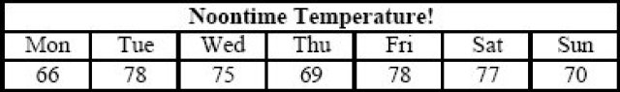
If m represents the median temperature, f represents the temperature that occurs most often, and a represents the average (arithmetic mean) of the seven temperatures, which of the following is the correct order of m, f, and a?
Insideatriangularpark,thereisaflowerbedformingasimilar triangle. Around the flower bed runs a uniform path of such a width that the sides of the park are exactly double the corresponding sides of the flower bed. The ratio of areas of the path to the flower bed is:
1:1
3:1
1:3
1:2
Consider the following piecewise definition of the function f.
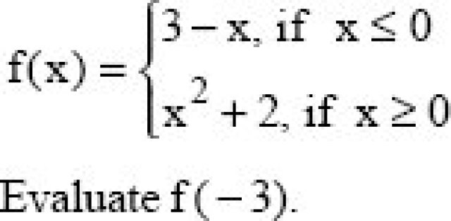
11
0
-7
6
A special lottery is to be held to select a student who will live in the only deluxe room in a hostel. There are 100 Year- Ill, 150 Year-II, and 200 Year-I students who applied. Each Year-III’s name is placed in the lottery 3 times; each Year-II’s name, 2 times; and each Year-I’s name, 1 time. What is the probability that a Year-III’s name will be chosen?
2/7
1/8
2/9
3/8
The average of nine numbers is M and the average of three of these is P. If the average of remaining numbers is N, then
3M = 2N + P
2M = N + P
3M = 2P + N
M = N + P
The intersection of two cubes cannot be
Cube
None of these
A rectangle
Triangle
In a factory, each day the expected number of accidents is related to the number of overtime hour by a linear equation. Suppose that on one day there were 1000 overtime hours logged and 8 accidents reported and on another day there were 400 overtime hours logged and 5 accidents. What is the expected number of accidents when no overtime hours are logged?
3
4
5
2
A rainy day occurs once in every 10 days. Half of the rainy days produce rainbows. What percent of all the days do not produce rainbow?
Bags I, II and III together have ten balls. If each bag contains at least one ball, how many balls does each bag have? Decide whether the data given in the statements are sufficient to answer the question.
Statement (1): Bag I contains five balls more than bag III.
Statement (2): Bag II contains half as many balls as bag I
Statement (2) Alone is sufficient, but statement (1) alone is not sufficient to answer the question asked.
EACH statement ALONE is sufficient to answer the question asked.
Statement (1) ALONE is sufficient, but statement (2) alone is not sufficient to answer the question asked.
BOTH statements (1) and (2) TOGETHER are sufficient to answer the question asked, but NEITHER statement ALONE is sufficient to answer the question asked
Area of a square natural lake is 50 sq. kms. A diver wishing to cross the lake diagonally, will have to swim a distance of
12 miles
10 miles
None of these
15 miles
If n = 1 + x, where x is the product of 4 consecutive positive integers, then which of the following is/are true?
n is odd;< br> n is prime
n is a perfect square< br>
1 and 3 only
1 only
1 and 2 only
None of these
How many arrangements can be formed out of the letters of the word EXAMINATION so that vowels always occupy odd places?
72000
64000
51600
86400
In a school drill, a number of children are asked to stand in a circle. They are evenly spaced and the 6th child is diametrically opposite the 16th child. How many children are made to stand in the circle?
None of these
16
20
22
A man purchased 40 fruits; Apples and oranges for Rs.17. Had he purchased as many oranges as apples and as many apples as oranges, he would have paid Rs.15/-. Find the cost of one pair of an apple and an orange.
60 paisa
80 paisa
70 paisa
1 paisa
Thenumber311311311311311311311is
Divisible by 3 but not by 11
Divisible by both 3 and 11
Divisible by 11 but not by 3
Neither divisible by 3 nor by 11
A man earns 6\% SI on his deposits in Bank A while he earns simple interest on his deposits in Bank B. If the total interest he earns is Rs.1800 in three years on an investment of Rs.9000, what is the amount invested at ?
6000
3000
4500
4000
Two identical trains A and B running in opposite directions at same speed take 2 minutes to cross each other completely. The number of bogies of A are increased from 12 to 16. How much more time would they now require to cross each other?
20s
60s
50s
40s
A ladder is lying against a wall which is 5 metres high. If the ladder slips 2 metres away from the wall, the top of the ladder touches the foot of the wall. The length of the ladder is
5m
7.25m
4m
5.25m
Directions : The following line graph shows the ratioofthewheatproductiontoriceproductionofastateinIndia over a period 7 years from 1999 – 2006. Answer the questions basedonthisdata.
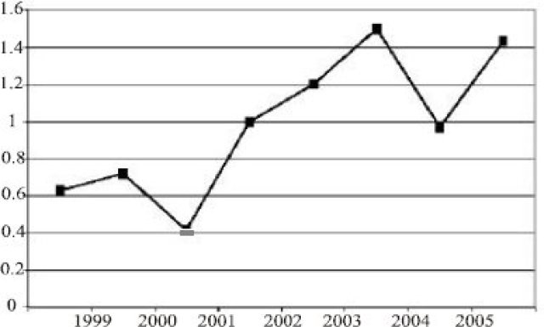
If the rice production in 2003 was 4 lac tons what was its wheat production during 2003?
4.8 lac tons
5.0 lac tons
3.6 lac tons
1.2 lac tons
Directions : The following line graph shows the ratioofthewheatproductiontoriceproductionofastateinIndia over a period 7 years from 1999 – 2006. Answer the questions basedonthisdata.
In how many years wheat production was more than the rice production?
4
3
2
5
Directions : The following line graph shows the ratioofthewheatproductiontoriceproductionofastateinIndia over a period 7 years from 1999 – 2006. Answer the questions basedonthisdata.
If the total annual grain requirement (wheat and rice together) of the state is 5 lac tons and if the rice production during 2001 was 3 lac tons, how much grain had to be imported from the other state of India to fulfill the requirement?
0.65 lac tons
1.55 lac tons
1.05 lac tons
2.00 lac tons
The profits of Biscuits India Ltd soared by 32% in the year 2006 – 07 as compared to year 2005 – 06. By what % did Biscuits India’s Sales increase in 2006 – 07 compared to the previous year? (Assume: Profit = Sales – Expenses) Decide whether the information given in the two statements is sufficient to solve the problem.
Statement(1): Expenses in 2006 – 07 were Rs 1,400 crores, as compared to Rs 1,220 crores in 2005 – 06
Statement (2): Sales in 2006 – 07 were Rs 4,300 crores
Each of the statement (1) or (2) taken alone, is sufficient to answer the question.
Both statements, taken together, are sufficient to answer the question, but neither of them alone is sufficient
Any one of the two statements (1) or (2) taken alone, is sufficient to answer the question.
Both the statements together are insufficient to answer the question.
Directions : Use the table about the speed of a train over a 3-hour period. The time count does not begin from starting of train
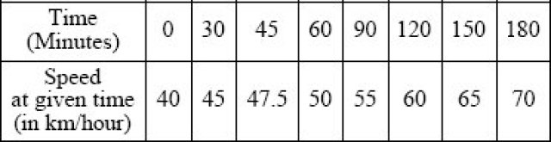
During the three-hour period shown in the table, the speed of the train increased by
Directions : Use the table about the speed of a train over a 3-hour period. The time count does not begin from starting of train
At time t, measured in minutes after the beginning of the time period, which of the following gives the speed of the train in accordance with the table?
40 + t/6
40 + t
t/6
6t
Directions : Use the table about the speed of a train over a 3-hour period. The time count does not begin from starting of train
How fast was the train travelling beginning of the time period?
50km/hr
60km/hr
65km/hr
55km/hr
In March 2007, Computers Ltd. made a bundled offer of its Laptops together with Deskjet printers to boost Sales, though both the Laptop and the printer were also available individually. What is the price of the Printer, if purchased separately? Decide whether the information given in the two statements is sufficient to solve the problem.
Statement(1): The bundled offer price was Rs 42,600
Statement(2): The Laptop, without the bundle offer was priced at Rs 39,400
Each of the statement (1) or (2) taken alone, is sufficient to answer the question
Both statements, taken together, are sufficient to answer the question, but neither of them alone is sufficient.
Both the statements together are insufficient to answer the question.
Any one of the two statements (1) or (2) is sufficient to answer the question
Directions : The following chart presents the datacollectedforanon-linejobportalInfiniteJobs.com.Foreach Question,therearetwoStatements,eachofwhichcouldbeeither TrueorFalse.Chooseoneofthefollowingoptionsasananswer:
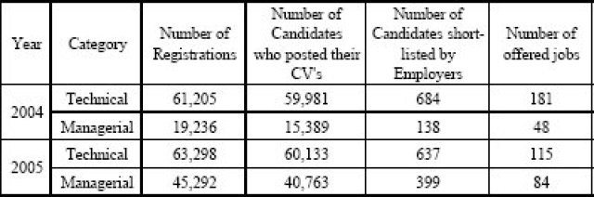
110. Statement X: The percentage increase in number of Registrations from 2004 to 2005 is higher for Managerial candidates than for Technical candidates
StatementX: The percentage increase in number of Registrations from 2004 to 2005 is higher for Managerial candidates than for Technical candidates
Both [X] and [Y] are True
Only [Y] is True
Neither [X] nor [Y] is True
Only [X] is True
Directions : The following chart presents the data collected for an on-line job portal InfiniteJobs.com.For each Question, there are two Statements, each of which could be either True or False.Choose one of the following options as ananswer:
StatementX: The percentage of drop-outs (from Registration stage to posting CV’s) had decreased from 2004 to 2005 for Managerial category
StatementY: The percentage of drop-outs was higher for Technical than for Managerial category in 2005
Neither [X] nor [Y] is True
Only [X] is True
Only [Y] is True
Both [X] and [Y] are True
Directions : The following chart presents the datacollectedforanon-linejobportalInfiniteJobs.com.Foreach Question,therearetwoStatements,eachofwhichcouldbeeither TrueorFalse.Chooseoneofthefollowingoptionsasananswer:
StatementX: The success rate of candidates getting short- listed based on CV’s is higher for Managerial category than for Technical category in 2005.
StatementY: The success rate of candidates getting short- listed based on CV’s is better for Managerial category in 2005 than in 2004
Neither [X] nor [Y] is True
Only [Y] is True
Both [X] and [Y] are True
Only [X] is True
Directions : The following chart presents the datacollectedforanon-linejobportalInfiniteJobs.com.Foreach Question,therearetwoStatements,eachofwhichcouldbeeither TrueorFalse.Chooseoneofthefollowingoptionsasananswer:
StatementX: In 2004, the number of candidates offered jobs as a proportion of the number of CV’s posted was higher for Technical than for Managerial candidates
Statement Y: In 2004, among those short-listed by Employers, the Technical category had a higher success rate in securing jobs than the Managerial category.
Neither [X] nor [Y] is True
Both [X] and [Y] are True
Only [X] is True
Only [Y] is True
Directions :The following table gives cost data of select stock prices on 3 rd Dec 2003 in two markets, BSE of India and NQE of Kya Kya island. Closing stock refers to the price at the close of trading hours and opening stock to the price at the beginning of the day. The currency of Kya Kya is # and the exchange rate is # = Rs 11.
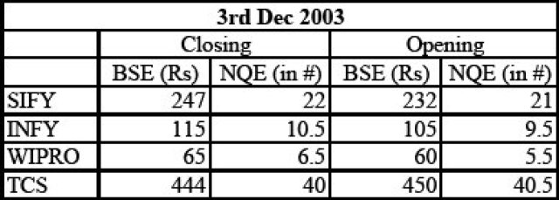
Directions :Thefollowingtablegivescostdataof select stock prices on 3 rd Dec 2003 in two markets, BSE of India and NQE of Kya Kya island. Closing stock refers to the price at the close of trading hours and opening stock to the price at the beginning of the day. The currency of Kya Kya is # and the exchange rate is # = Rs 11.
Which share and which market showed the highest % increase on 3 rd Dec 2003?
INFYonNQE
TCS on NQE
SIFYonBSE
Wipro on NQE
Directions :The following table gives cost data of select stock prices on 3 rd Dec 2003 in two markets, BSE of India and NQE of Kya Kya island. Closing stock refers to the price at the close of trading hours and opening stock to the price at the beginning of the day. The currency of Kya Kya is # and the exchange rate is # = Rs 11.
Arbitrage means buying in one market and selling simultaneously in another market. If Mr. Ghosh Babu were to buy a share at the opening price on one exchange and be able to sell it at the opening price on the other exchange, on which share does he make maximum % profit?
INFY
Wipro
SIFY
TCS
Directions :The following table gives cost data of select stock prices on 3 rd Dec 2003 in two markets, BSE of India and NQE of Kya Kya island. Closing stock refers to the price at the close of trading hours and opening stock to the price at the beginning of the day. The currency of Kya Kya is # and the exchange rate is # = Rs 11.
In an M&A deal SIFY is purchased by its parent company SATYAM which purchases 15% of SIFY’s equity shares. Total SIFY’s equity shares is 1 million. How much does Satyam pay in Rs. for the stake if 50% of its purchases were on BSE’s operating price and balance on BSE’s closing price?
217million
36million
363million
3.5million
Directions :The following pie-charts give the percentage distribution of employees in different Departments in XYZ Company Ltd. during the years 2005 and 2006. Answer the questions using this data
A-Administration; B-Operations; C-Sales & Marketing;
D-Finance&Accounts;E-CorporateHQ
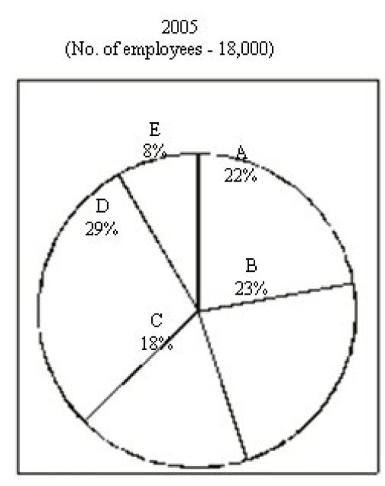
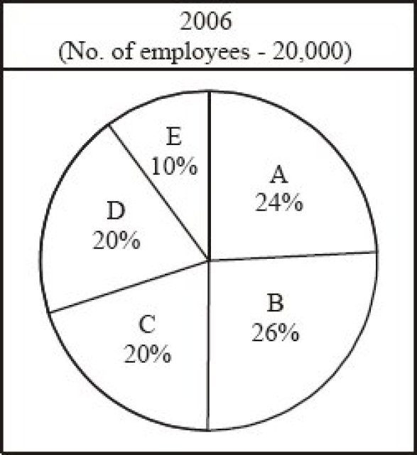
If the average monthly salary of employees in Administration was Rs 12,000 in 2005, what was the approximate total Salary expense of Administration in 2005?
Rs. 57 lakhs
Rs. 66 lakhs
Rs. 66 crores
Rs. 4.7 crores
Directions :The following pie-charts give the percentage distribution of employees in different Departments in XYZ Company Ltd. during the years 2005 and 2006. Answer the questions using this data
A-Administration; B-Operations; C-Sales & Marketing;
D-Finance&Accounts;E-CorporateHQ
What is the percentage increase in No. of employees in Sales & Marketing?
None of these
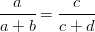
Directions :The following pie-charts give the percentage distribution of employees in different Departments in XYZ Company Ltd. during the years 2005 and 2006. Answer the questions using this data
A-Administration; B-Operations; C-Sales & Marketing;
D-Finance&Accounts;E-CorporateHQ
In which Dept is the variation in strength the maximum in 2006?
E
D
B
A
Directions :The following pie-charts give the percentage distribution of employees in different Departments in XYZ Company Ltd. during the years 2005 and 2006. Answer the questions using this data
A-Administration; B-Operations; C-Sales & Marketing;
D-Finance&Accounts;E-CorporateHQ
If 300 employees left Operations at the end of 2005, how many joined in 2006?
1360
None of these
960
480
You have three chests in front of you. The first chest is labeled “GOLD”, the second is labeled “SILVER” and the third is labeled “GOLD OR SILVER”. You have been told that all the labels are on the wrong chests and that one chest contain gold coins, one contains silver coins and one contains bronze coins. How many chests do you need to open to deduce which label goes on which chest?
0
Cannot deduce
1
2
How many minutes before 12 noon is it when it is 27 minutes past 10 am?
93
94
49
30
Directions Read the following passage and answer thequestions.
An employee has been assigned the task of allotting offices to six of the staff members. The offices are numbered 1 – 6. The offices are arranged in a row and they are separated from each other by six foot high dividers. Hence voices, sounds and cigarette smoke flow easily from one office to another.
Miss Ruby needs to use the telephone quite often throughout the day. Mr. Minhas and Mr. Brar need adjacent offices as they need to consult each other often while working. Miss Harsha is a senior employee and has to be allotted the office number 5, having the biggest window.
Mr. Dongre requires silence in the offices next to his. Mr. Tanjore, Mr. Minhas and Mr. Dongre are all smokers. Miss Harsha finds tobacco smoke allergic and consequently the offices next to hers are to be occupied by non-smokers.
Unless specifically stated all the employees maintain an atmosphere of silence during office hours.
The ideal candidate to occupy the office furthest from Mr. Brar would be
Mr. Dongre
Miss Harsha
Mr.Tanjore
Mr. Minhas
Directions Read the following passage and answer thequestions.
An employee has been assigned the task of allotting offices to six of the staff members. The offices are numbered 1 – 6. The offices are arranged in a row and they are separated from each other by six foot high dividers. Hence voices, sounds and cigarette smoke flow easily from one office to another.
Miss Ruby needs to use the telephone quite often throughout the day. Mr. Minhas and Mr. Brar need adjacent offices as they need to consult each other often while working. Miss Harsha is a senior employee and has to be allotted the office number 5, having the biggest window.
Mr. Dongre requires silence in the offices next to his. Mr. Tanjore, Mr. Minhas and Mr. Dongre are all smokers. Miss Harsha finds tobacco smoke allergic and consequently the offices next to hers are to be occupied by non-smokers.
Unless specifically stated all the employees maintain an atmosphere of silence during office hours.
The three employees who are smokers should be seated in the offices.
1, 2 and 3
1, 2 and 6
1,2 and 4
2, 3 and 6
Directions Read the following passage and answer thequestions.
An employee has been assigned the task of allotting offices to six of the staff members. The offices are numbered 1 – 6. The offices are arranged in a row and they are separated from each other by six foot high dividers. Hence voices, sounds and cigarette smoke flow easily from one office to another.
Miss Ruby needs to use the telephone quite often throughout the day. Mr. Minhas and Mr. Brar need adjacent offices as they need to consult each other often while working. Miss Harsha is a senior employee and has to be allotted the office number 5, having the biggest window.
Mr. Dongre requires silence in the offices next to his. Mr. Tanjore, Mr. Minhas and Mr. Dongre are all smokers. Miss Harsha finds tobacco smoke allergic and consequently the offices next to hers are to be occupied by non-smokers.
Unless specifically stated all the employees maintain an atmosphere of silence during office hours.
In the event of what occurrence, within a period of one month since the assignment of the offices, would a request for a change in office be put forth by one or more employees?
Miss Ruby needs silence in the office (s) next to her own.
Mr. Dongre quitting smoking
The installation of a noisy teletype machine by Miss Harsha in her office.
Mr. Tanjore taking over the duties formerly taken care of by Miss Ruby.
Shankar and Jwala are both members of a Youth club, though they are not speaking to each other and refuse to work with each other. Chaya, the club president, is appointing members to the fundraising committee, but she has resolved that she will not appoint anyone without his or her explicit consent. Shankar tells Chaya, “I will not consent to appointment on that committee unless I know whether Jwala is to be a member of it.” And Jwala says, “I will not consent to be a member of that committee unless I know whether Shankar will be appointed to it.”
If all three of these people stick by these resolutions, then:
Either one of them can be appointed, but not both.
Neither of them can be appointed to the committee.
The committee may finally have one of them, both of them, or neither of them as members.
They must either both be appointed or both be left out.
A bank customer had Rs. 100 in his account. He then made 6 withdrawals, totaling Rs. 100. He kept a record of these withdrawals, and the balance remaining in the account, as follows:
Withdrawals  Rs.50  Rs.25  Rs.10  Rs.8  Rs.5  Rs.2  Rs.100 | Balanceleft  Rs.50  Rs.25  Rs.15  Rs.7  Rs.2  Rs.0  Rs.99
So, why are the totals not exactly right?
The bank has cheated the customer.
The two totals need not be equal.
There is a mistake in the total of the balance.
There is a mistake in the total of withdrawals.
Which image from the bottom row should replace the question mark?
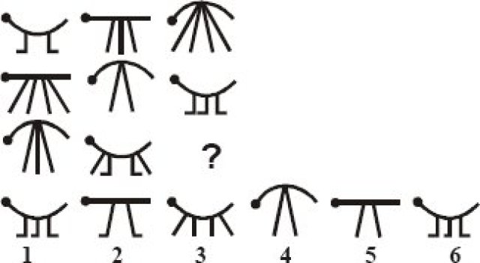
6
2
5
3
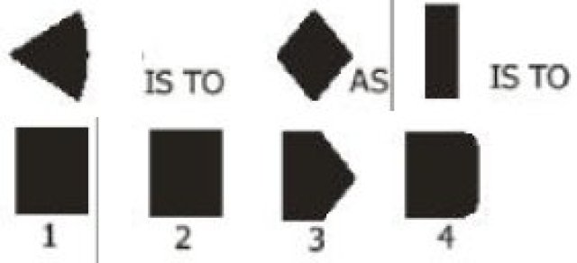
4
2
3
1
Which pattern from the bottomline (A,B,C,DorE) is missing from the top line?
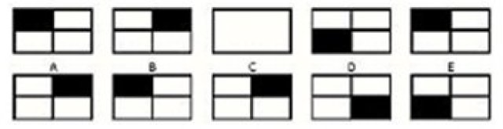
B
D
A
E
These questions are based on the following information.
During their school Silver Jubilee Reunion, four alumni were discussing their starting annual salaries back in 1981. The salaries in question were Rupees 40, 50, 60 and 70 thousand per year. Of course the present MD of a private company earned the most. Arvind earned more than Biswajeet, and the doctor earned more than Dhruv the engineer. Chinmay could not remember what he started on. Biswajeet the lawyer did not start on Rs.50,000, nor did Dhruv
What is Chinmay’s current profession?
Engineer
MD
Doctor
Lawyer
These questions are based on the following information.
During their school Silver Jubilee Reunion, four alumni were discussing their starting annual salaries back in 1981. The salaries in question were Rupees 40, 50, 60 and 70 thousand per year. Of course the present MD of a private company earned the most. Arvind earned more than Biswajeet, and the doctor earned more than Dhruv the engineer. Chinmay could not remember what he started on. Biswajeet the lawyer did not start on Rs.50,000, nor did Dhruv
What was the Lawyer’s starting salary?
70,000
60,000
50,000
40,000
These questions are based on the following information.
During their school Silver Jubilee Reunion, four alumni were discussing their starting annual salaries back in 1981. The salaries in question were Rupees 40, 50, 60 and 70 thousand per year. Of course the present MD of a private company earned the most. Arvind earned more than Biswajeet, and the doctor earned more than Dhruv the engineer. Chinmay could not remember what he started on. Biswajeet the lawyer did not start on Rs.50,000, nor did Dhruv
Who received the highest starting salary?
Arvind
Dhruv
Biswajeet
Chinmay
A man has a job which requires him to work 8 straight days and rest on the ninth day. If he started work on a Monday, the 12th time he rests will be on what day of the week?
Wednesday
Sunday
Tuesday
Friday
From the images below (1-7) find 3 odd ones out.
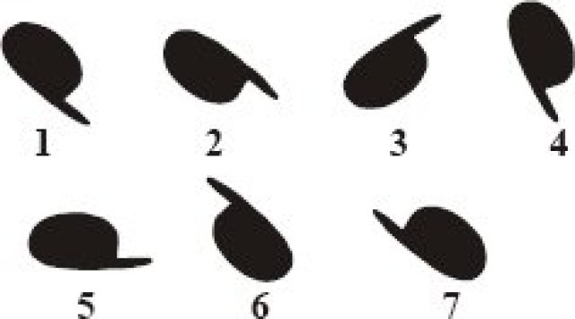
4,1,6
2,3,7
3,7,4
1,2,3
Babloo and Bunty were excitedly describing the result of the First Annual Running Race at Damapur High School. Snehal, Tanmay and Waman had been the three contestants. “Tanmay won the race; Waman was in second place,” reported Babloo. Bunty disagreed. “It was Snehal who won. Tanmay came second.”
In fact, neither Babloo nor Bunty had given a correct version of the result as each had made one true and one false statement.
What was the actual placing of the three contestants?
Tanmay, Waman, Snehal.
Waman, Snehal, Tanmay.
Snehal,Tanmay, Waman.
Snehal,Waman,Tanmay.
What is the number of routes from P to Q?
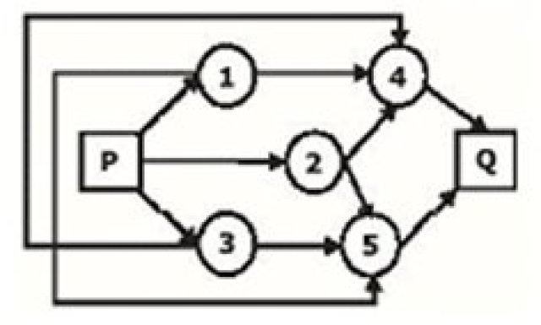
12
6
9
5
Find the circle, which does not include a word using all letters.
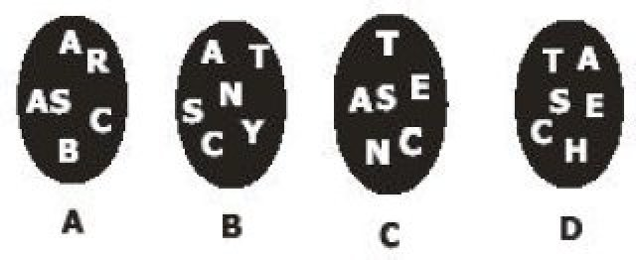
A
B
D
C
It is possible to arrange eight of nine numbers 2,3,4,5,7,10,11,12,13 in the vacant squares of the 3 by 4 array shown below so that the arithmetic average of the numbers in each row and column is the same integer.
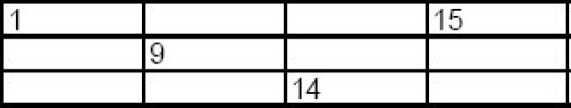
Which of the nine numbers must be left out when completing the array?
15
10
7
4
Which of the nine numbers must be left out when completing the array?
19
24
40
18
Where should the letter ‘W’ be placed?
Above
Above
Above
Above
At a family reunion were the following people: one grandfather, one grandmother, two fathers, two mothers, four children, three grandchildren, one brother, two sisters, two sons, two daughters, one father-in-law, one mother-in-law, and one daughter-in-law. But not as many people attended as it sounds. How many person were there?
5
15
7
10
On the counter are six squares marked 1, 2, 3, 4, 5, 6. Players are invited to place as much money as they wish on any one square. Three dice are then thrown.
If the number is not on any of the dice, the operator gets your money.
If your number appears on all three dice, you get your money back plus three times the amount.
If your number appears on one die only, you get your money back plus the same amount
If two dice show your number, you get your money back plus twice the amount you placed on the square.
On the counter are six squares marked 1, 2, 3, 4, 5, 6. Players are invited to place as much money as they wish on any one square. Three dice are then thrown.
1. If your number appears on one die only, you get your money back plus the same amount.
1. If two dice show your number, you get your money back plus twice the amount you placed on the square.
1. If your number appears on all three dice, you get your money back plus three times the amount.
1. If the number is not on any of the dice, the operator gets your money
For example, suppose that you bet one Rupee on square No. 6. If one die shows a 6, you get your Rupee back plus another Rupee. If two dice show 6, you get back your Rupee plus two Rupees. If three dice show 6, you get your Rupee back plus three Rupees.
From a player’s point of view, the chance of his number showing on one die is 1/6, but since there are three dice, the chances must be 3/6 or 1/2, therefore the game is a fair one. Of course this is the way the operator of the game wants everyone to reason, for it is quite fallacious.
What is the probable story?
The player suffers a loss of 6% on each Rupee bet.
Operator gets a profit of 7.8% on each Rupee bet.
Operator suffers a loss of 7.8% on each Rupee bet.
Operator gets a profit of 6% on each Rupee bet.
Jaideep was given some money by his mother on his birthday. Jaideep spent all of it in five stores. In each store he spent one rupee more than half of what he had when he came in. How much did he get from his mother?
Rs.25
Rs.52
Rs.30
Rs.46
Consider the following two statements to be true if they seem to be at variance from commonly known facts. Then decide which of the given conclusions logically follows from two given statements. Select the correct alternative.
Statements: All Lawyers are extrovert.
Some wise men are extrovert.
Conclusions: (ja)All lawyers are wisemen. (jb) All wisemen are lawyers. (jc) Some extrovert are wisemen. (jd) All extrovert are lawyers
Only (jc) follows.
Only (jb) and (jc) follows.
Only (ja) and (Jc) follows.
Only (ja) follows.
The following are the results of a survey conducted on a small cross-section of students from Symbiosis Group of institutes, to determine the readership of three magazines. This survey was conducted in Dec. 2006.
- Number of students who read only Business India was 40
- 60 students read only Outlook
- 110 students read only India Today
- 30 students read all three magazines
- 20 read Business India and India Today, but not Outlook
- 50 read Business India and Outlook, but not India Today
- 40 read Outlook and India Today, but not Business India
What was the total no. of students surveyed?*
210
None of these
350
390
The following are the results of a survey conducted on a small cross-section of students from Symbiosis Group of institutes, to determine the readership of three magazines. This survey was conducted in Dec. 2006.
- Number of students who read only Business India was 40
- 60 students read only Outlook
- 110 students read only India Today
- 30 students read all three magazines
- 20 read Business India and India Today, but not Outlook
- 50 read Business India and Outlook, but not India Today
- 40 read Outlook and India Today, but not Business India
How many students did not read Business India?
When another survey was conducted in May 2007 with the same set of students, their tastes had changed and the findings were different. All of them read India Today. 120 read Outlook, and no one read Business India. Hence, in May 2007, how many students read only India Today?
110
230
None of these
60
An ingredient in coffee, known as RTC, has been found to inactivate common cold viruses in experiments. In previous experiments, researchers found that inactivated common cold viruses can convert healthy cells into cancer cells. It can be concluded that the use of coffee can cause cancer. Which one of the following, if true, most seriously weakens the argument?
Several teams of scientists performed the various experiments, and all of the teams had similar results.
When RTC kills common cold viruses it weakens the immune system, and it might thus diminish the body’s ability to fight other viruses, including viruses linked to cancers.
If chemists modify the structure of RTC, RTC can be safely incorporated into medications to prevent the common cold.
The carcinogenic effect of RTC could be neutralized by the other ingredients found in coffee.
A census taker approaches a house and asks the woman who answers the door, “How many children do you have, and what are their ages?”
Woman: “I have three children, the product of their ages is 36, the sum of their ages is equal to the address of the house next door.”
The census taker walks next door, comes back and says, “I need more information.”
The woman replies, “I have to go, my oldest childis sleeping upstairs.”
9,2,2
12,3,1
6,3,2
6,6,1

